Linux Basic Assignment

#task1

* mkdir command used to create new dir.
* touch command used to create empty files.
* mv command used to copy or rename content from source to destination. In here we used to rename example.txt to renamed_example.txt.

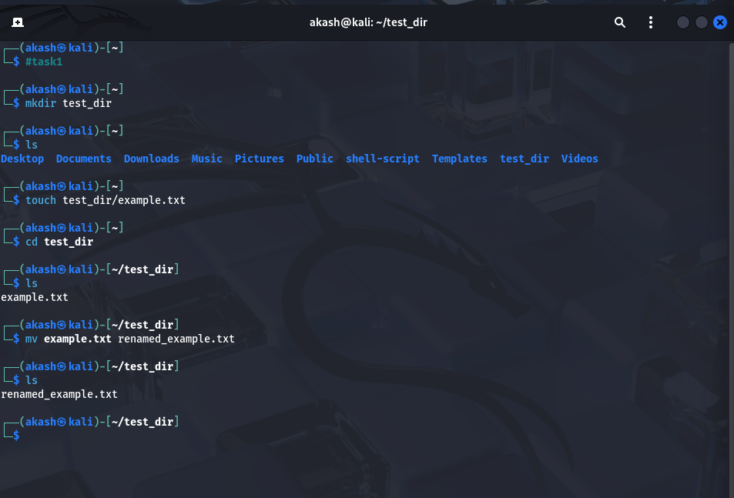

#task2

* cat command used to display the contents of a file .
* head command used to display some start/top contents of the file here we display only 5 lines using head command.
* tail command used to display some end/last contents of file here we display only 5 lines using tail command.

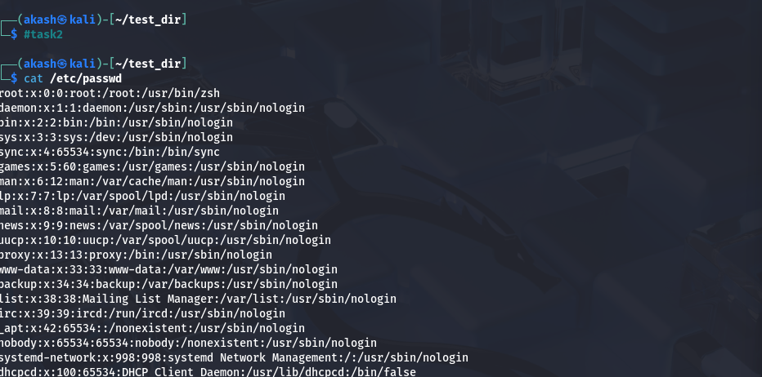

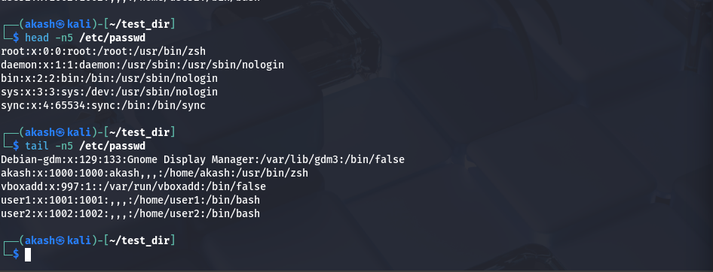

#task3

* grep command used to search patterns in the files
* In the first grep command we use -i for case insensitive and second command is case sensitive.

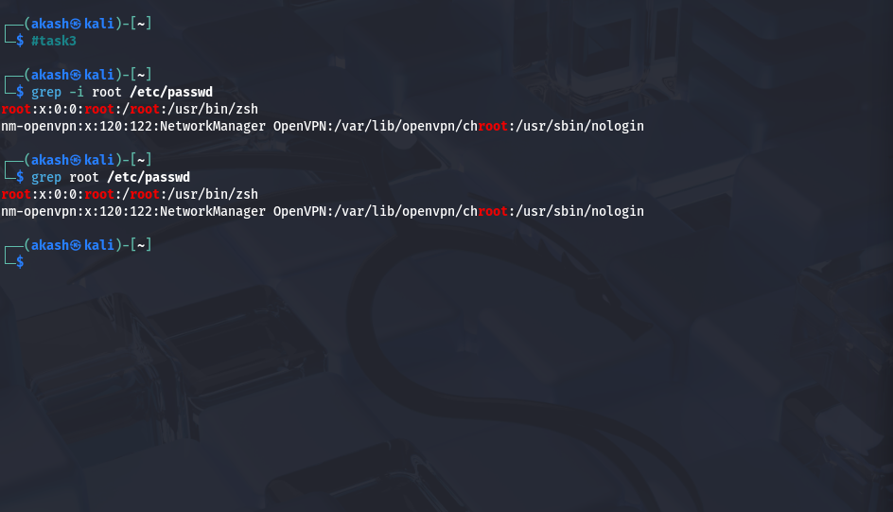

#task4

* zip command used to zip the content of a file . here -r used for recursive means recursively zipped files and dir inside test_dir.
* unzip command used to unzip the content of a file into a new folder called unzipped_dir.

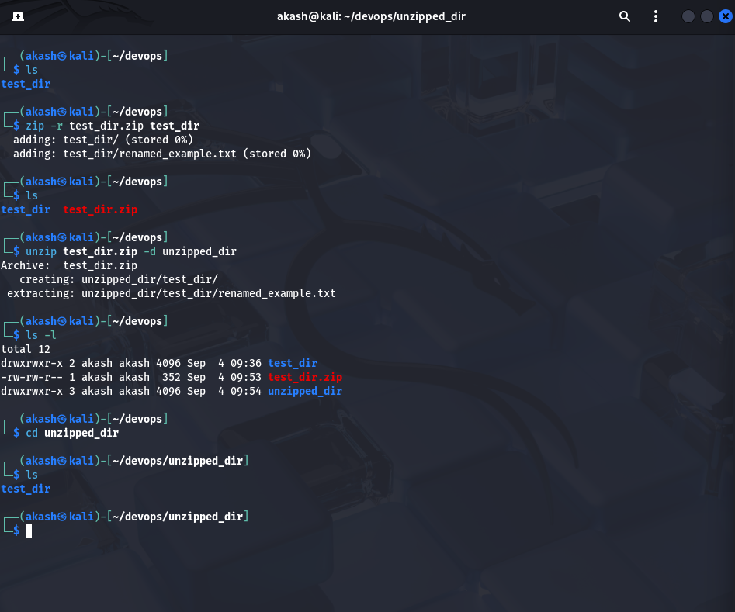

#task5

* wget command used to download content/files from the web . below we download a file from web and show its content.

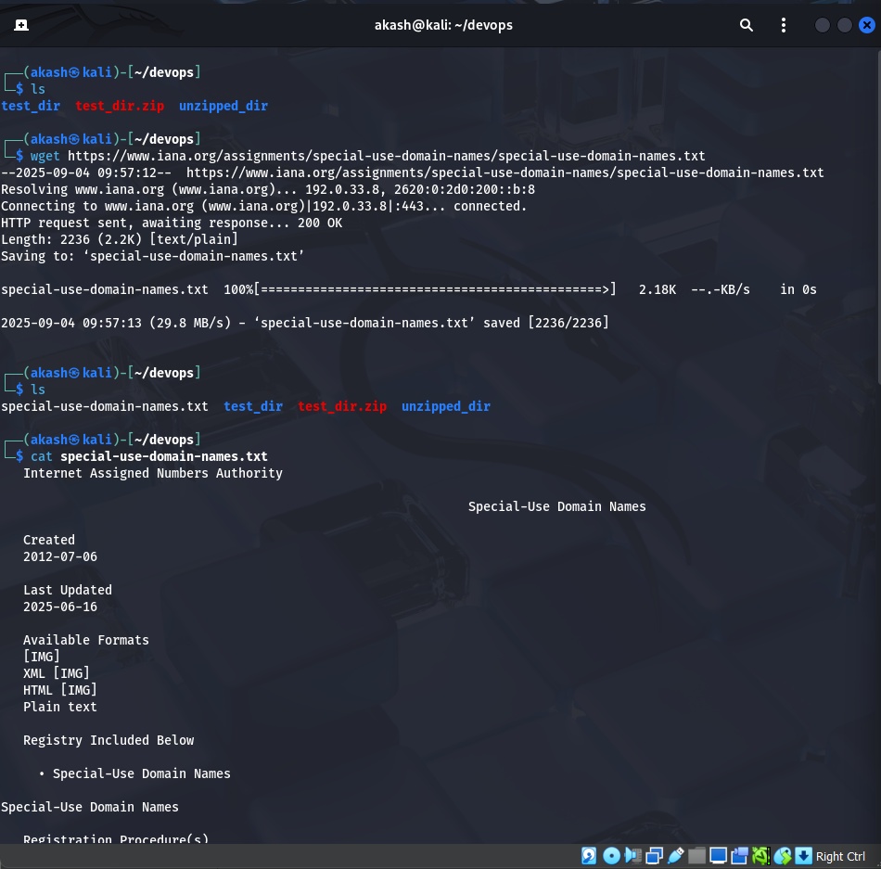

#task6

* chmod command used to change the file/dir permission. Means who can read,write or execute the file.
* In the below example we give only read permission to file named secure.txt

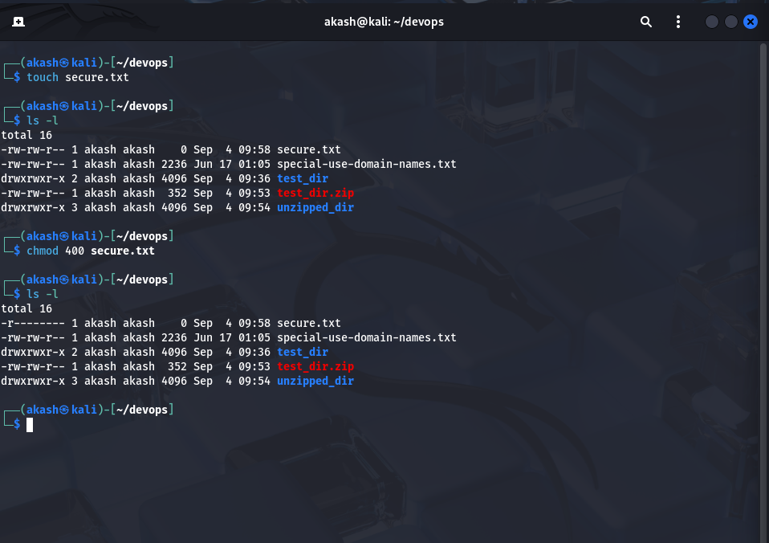

#task7

* export command used to set the environment variable for current terminal session or we can say for current process/child processes.

